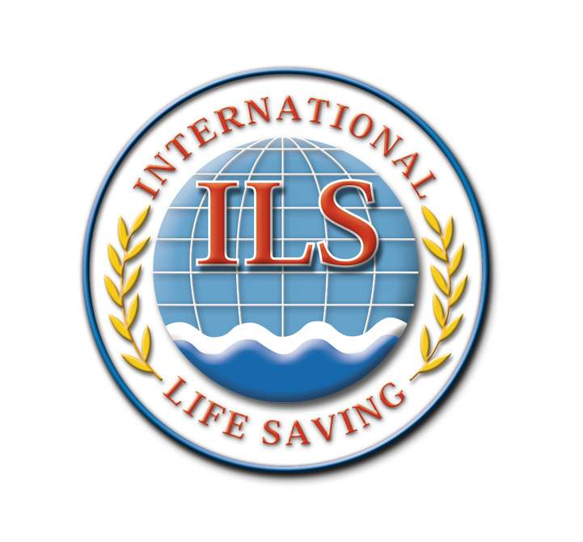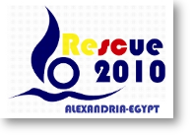
Communiqué – January 2010
RESCUE 2010 – Lifesaving World Championship – October 4-16, 2010
Notice of change to ILS Competition Manual
An update for competitors, coaches and officials on changes to
Section 3.3 Team Uniforms and Equipment
in the ILS Competition Manual (2009 edition) that apply at the 2010 World Lifesaving Championships.

DRESS OF COMPETITORS – Costumes, Dress and Style
Competitors shall wear costumes, clothing or dress as approved by ILS.
A competitor shall be not be permitted to take part in any competition if, in the opinion of the Referee, the competitor is not properly dressed.
Swimwear for both ILS pool rescue competition and ocean events must comply with the following standards:
- Swimwear worn by males shall not extend above the navel or below the knee.
- Swimwear worn by females shall not cover the neck, shoulders or arms nor extend below the knees. Two piece swimsuits that conform to this standard may also be worn.
Male Swimsuits
Full Length | Long | Long Legs | Knee length | Square Leg | Short
Not Allowed | Not Allowed | Not Allowed | Allowed | Allowed | Allowed
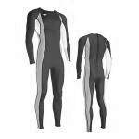 | 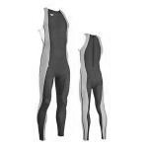 | 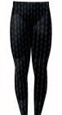 | 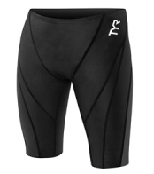 | 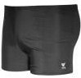 | 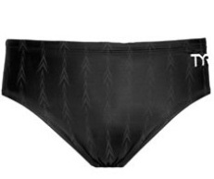

Female Swimsuits
Full Length | Zippered Back | Knee Length, Open Back | Short, Open Back | Two Piece
Not Allowed | Not Allowed | Allowed | Allowed | Allowed
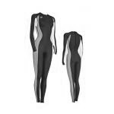 | 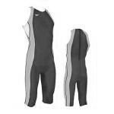 | 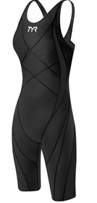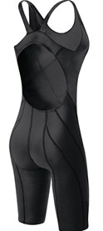 | 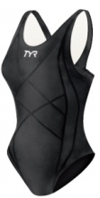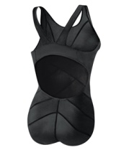 | 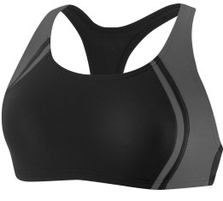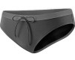
The material and construction used in swimwear to be worn in all ILS pool rescue events and ocean competition event swim legs shall be:
- Only textile woven fabric(s) shall be permitted.
- Non-woven and/or non-permeable (e.g. wetsuit type) materials shall not be permitted.
- The material used shall have a maximum thickness of 0.8mm.
- Other than string ties for the tops of men’s swimwear or the bottom of female two piece swimwear no zippers or other fastening systems shall be permitted.
- Swimwear that provides flotation, pain reduction, chemical/medical stimulation or other external stimulation or influence of any type shall be prohibited.
- No outside application on the material shall be permitted. (Note: manufacturer brandings, club names or similar are permitted).
ILS will allow both male and female competitors to wear "modesty" swimwear made of a textile woven fabric under their swimsuit, provided that no competitive advantage is gained. Further, any modesty swimwear shall be restricted to the short style for men and the two piece style top and/or bottom for women.
Upon application for religious and/or cultural diversity reasons, ILS will consider the wearing of (non-body shaping) textile swimwear that covers a greater part of the body provided that such swimwear does not provide a competitive advantage.
The Referee may authorise the wearing of wetsuits or "marine stinger suits" dependent upon weather, water or other marine conditions.
Wetsuits shall be permitted in events when the water temperature is 16 degrees Celsius or less, or when the Referee determines wind chill is a factor. Water temperature measurements should be taken approximately 30 cm below the surface.
The only wetsuits approved for use in events involving swimming shall have a maximum thickness of 3 mm at any location on the wetsuit with a tolerance of 0.3 mm. Wetsuits cannot contain additional material to provide the wearer with flotation or buoyancy assistance. It is not permitted to wear more than one wetsuit (i.e. one upon the other) but one modesty textile swimsuit is permitted.
Except for swimmers in events the wearing or other protective clothing (e.g. shorts, Lycra tops,
t-shirts, etc.) may be worn by individual competitors in both individual and team events unless otherwise prescribed by these rules or the event organizing authority.
In addition, the following also applies to particular events:
- In Surf Boat events the Sweep Oarsman may wear apparel (including wetsuits and booties) as the conditions warrant. The specifications for wetsuits shall not apply.
- In IRB events competitors may wear apparel (including wetsuits, booties, gloves and hoods) in all events. The specifications for wetsuits shall not apply.
- Competitors may also be required to wear distinctive coloured vests to assist with judging of finishes. Such vests will be supplied by ILS.
Sunglasses or optical glasses may be worn in all events provided that any eye protection or optical glasses worn must be suitably designed for that event.
For more information, contact the Technical and Rules Committee through the ILS web site, www.ilsf.org and email ilshq@telenet.be.

